**Joining Report**

To,

The Placement Department,

Mukesh Patel School of Technology Management & Engineering,

NMIMS University,Mumbai.

Respected Sir,

As per your instructions, I have reported for the Inplant Training Program. SEM (XI / XII)

In (Organization Name) ______E-RevBay Pvt. Ltd.____________________________

On (DD/MM/YY) _____05/12/22_____________ at (Time) _____11:00______ AM.

Yours obediently,

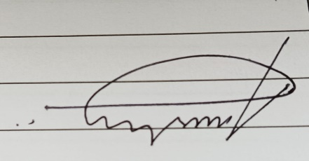 _____________________________

Signature of the Student Signature of the Officer of the Industry:

Name: Anirbaan Ghatak Name:

Roll No: C026 Designation:

SAP Id: 70321019026 Contact No:

Branch: Computer Engineering Email Id:

Seal/ Stamp of the Industry